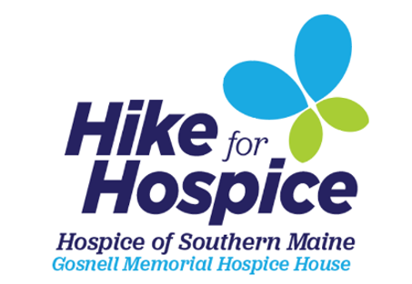

Registration Form
Registration is also available online at hikeforhospice.org. Send completed forms along with payment by October 4, 2021 to: Hospice of Southern Maine, 390 US Route One, Scarborough, ME 04074. Please complete a form and signed waiver for each Hike for Hospice participant. Please call 207-289-3640 with any questions.

Participant:
Name
Address: City: State: Zip:
Phone: |  | Email:
Team Name (Optional):
$25 Team Captain I will be walking in person on 10/16/21*
$25 Team Member I will be walking virtually (when and where I choose)
$25 Individual
$10 Pet

* If COVID prevents us from holding an in-person event in 2021, you will be notified by September 1st.

All registered participants receive a Hike for Hospice t-shirt. If you’re walking in person on October 16th please pick up your t-shirt at registration. If you are participating virtually, your t-shirt will be mailed to you.
T-shirt Size: (Please circle one)
Adult: XS S M L Xl XXL
Signature: | Signature:
(If under age 18, parent or guardian must also sign) Parent or Guardian Signature |  |  | (if applicable)

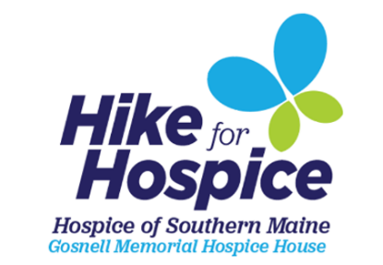

Waiver Form

In consideration of accepting this entry into the Hike for Hospice event (the “Event”), I, the participant, intending to be legally bound do hereby waive, release, hold harmless, and forever discharge any and all rights, liabilities, losses, and claims that I may have against Hospice of Southern Maine, the Theresa M. Desfosses revocable trust, Theresa M. Desfosses, State Manufactured Homes, Inc, Eastern Trail Alliance, and all of their directors, trustees, officers, employees, volunteers, and agents for any and all injuries or harm I may suffer at or in connection with the Event, including damage to personal property. Without limiting the foregoing, this waiver includes all injuries and/or damages suffered by me before, during or after the Event. I recognize, intend and understand that this waiver is binding on my heirs, executors, administrators, and assignees.
I know that participating in the Event is a potentially hazardous activity. I will not enter the Event unless I am medically able and properly trained. I agree to abide by all decisions concerning the Event by the organizers of the Event. I fully assume all risks associated with participating in the Event including but not limited to falls, contact with other individuals, weather effects including cold, rain, heat and humidity, traffic and road conditions. Having read this waiver, knowing these facts, I, for myself and anyone entitled to act on my behalf, waive and release the above parties and all sponsors, their representatives and successors from all claims of liabilities of any kind arising out of my participation in the Event, including any claims for negligence, the action or inaction of any of the above parties, or otherwise.
I understand the Event takes place rain or shine. No refunds will be given.
Further, I grant permission to all the foregoing to use my name, voice and images of myself in any photographs, motion pictures, results, publications or any other print, videographic or electronic recording of the Event for legitimate purposes.
All participants in the Event are expected to adhere to all Maine CDC and U.S. CDC guidelines, including wearing a mask, not gathering in groups of 50 or more and practicing social distancing.
By submitting this entry, I acknowledge that I have read this Waiver Form and that I understand and agree to it. For any entrants under 18 years of age, a parent or guardian must agree to this Waiver Form on the entrant’s behalf.

Printed Name: _______________________________________

Signature: __________________________________________ Date: _______________

